***Biology notes:***

***Topic 2 – Organisation:***

**Cell Organisation**

Large multicellular organisms are made up of organ systems

* Cells are the basic building blocks which make up all living organisms
  + Specialised cells carry out a specific function
    - The process by which cells become specialised for a particular job is called differentiation
      * Differentiation occurs during the development of a multicellular organism
  + These specialised cells form:
    - Tissues
      * A tissue is a group of similar cells that work together to carry out a particular function
      * It can include more than one type of cell
    - Which then form organs
      * An organ is a group of tissues that work together to perform a certain function
    - Which from organ systems
      * An organ system is a group of organs working together to perform a particular function
* Large multicellular organisms (e.g. squirrels) have different systems inside them for exchanging and transporting materials

**Enzymes**

Enzymes are catalysts produced by living things

* Chemical reactions need to be carefully controlled
* You can usually make a reaction happen quicker by raising the temperature
  + However, this can also speed up reactions which you don’t want to speed up
  + There is also a limit on how much you can raise it before the cells start getting damaged
* Living things produce enzymes that acct as biological catalysts
  + Enzymes reduce the need for high temperatures
  + They only speed up useful reactions
* A catalyst is a substance which increases the speed of a reaction without being changed or used up in the reaction
* Enzymes are all large proteins
  + All proteins are made up of chains of amino acids
  + These chains fold into unique shapes
    - These shapes are needed by enzymes to do their jobs
* Chemical reactions usually involve things either being split apart of join together
* Every enzyme has an active site with a unique shape that fits onto the substance involved in a reaction
  + They only catalyse with one specific reaction
    - This is because, for the enzyme to work, the substrate has to fit into the active site
      * If the substrate doesn’t match the active site, then the reaction won't be catalysed
* Simple lock and key diagram
  + In reality, the active site changes shape a little as the substrate binds to it
    - This means it gets a tighter fit, it is called the ‘induced fit’

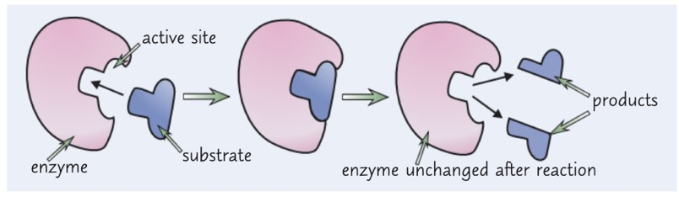

* Enzymes need the optimum temperature and pH levels
  + If it’s too hot or too acidic or alkaline, the enzymes can be denatured
    - This means that the active site has changed shape
      * This means the substrate won't fit anymore
* 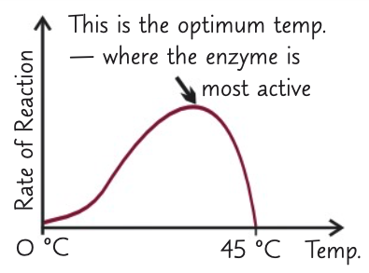It is easy to read this on a graph:

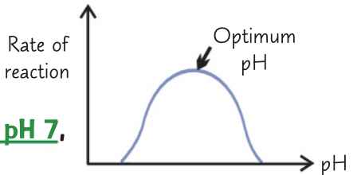

**Investigating Enzymatic Reactions - Practical**

You can investigate the effect of pH on Enzyme activity

Equipment:

* 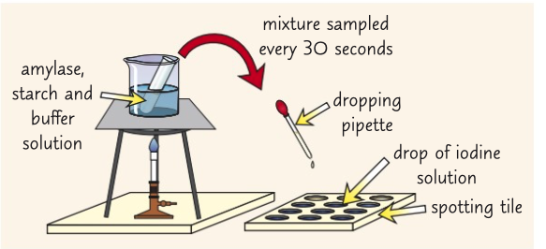Spotting tile
* Bunsen burner
* Heat proof mat
* Tripod
* Gauze
* Thermometer
* Syringe
* Test tube
* Test tube holders
* Stopwatch
* Dropping pipette

Method

1. Put a drop of iodine solution into every well of a spotting tile
2. Place a Bunsen burner on a heat proof mat and a tripod and gauze over the Bunsen burner
   1. Put a beaker of water on top of the tripod and heat the water until it is 35°C (using a thermometer)
   2. Try to keep the water temperature constant
3. Use a syringe to add 1cm3 of amylase solution and 1cm3 of a buffer solution with a pH of 5 to a boiling tube.
   1. Using test tube holders, put the tube into the beaker of water and wait for 5 minutes
4. Next, use a different syringe to add 5cm3 of a starch solution to the. Oiling tube
5. Mix the contents and start a stop clock
6. Use continuous sampling to record how long it takes for the amylase to break down all of the starch
   1. To do this, use a dropping pipette to take a fresh sample from the boiling tube every 30 seconds and put a drop into a well
   2. When the iodine solution remains browny orange, starch is no longer present
7. Repeat the whole experiment with buffer solutions which have different pH values and see how it affects the time taken for the starch to be broken down

* Rate of reaction:
  + Rate is a measure of how much something changes over time
  + For the experiment above, you can calculate the rate of reaction using this formula
    - Rate = 1000 / time
  + If an experiment measures how much something changes over time, you use the formula
    - Change / Time taken

**Enzymes and Digestion**

* Digestive enzymes break down big molecules
* Starch, proteins and fats are big molecules
  + They’re too big to pass through the walls of the digestive system
  + Therefore, they are broken down into smaller ones such as:
    - Sugars, amino acids, glycerol and fatty acids
  + These smaller, soluble molecules can pass easily through the walls of the digestive system, allowing them to be absorbed into the bloodstream
* Carbohydrase’s convert carbohydrates into simple sugars
  + Amylase 🡪 Starch
    - Amylase is made in three places:
      * The salivary glands
      * The pancreas
      * The small intestine
* Protease enzymes convert proteins into amino acids
  + Proteases are made in three places:
    - The stomach (where it’s called pepsin)
    - The pancreas
    - The small intestine
* Lipase enzymes convert lipids into glycerol and fatty acids
  + Lipids are made in two places:
    - The pancreas
    - The small intestine
* The body make good use of the products of digestion.
* They can be used to make new carbohydrates, proteins and lipids
* Some of the glucose which is made is used in respiration
* Bile neutralises the stomach acid and emulsifies fat
  + Bile is produced in the liver. It’s stored in the gall bladder before its released into the small intestine
  + The hydrochloric acid in the stomach makes pH too acidic for enzymes n the small intestine to work properly
    - Bile is an alkaline which neutralises the acid and allows the enzymes to work best
    - It emulsifies fat
      * This means that it breaks down the fat into tiny droplets, this gives a bigger surface area of fat for the enzyme lipase to work on, which makes digestion faster
* Enzymes used in the digestive system are produced by specialised cells in glands and in the gut lining
* Different enzymes catalyse the breakdown of different food molecules

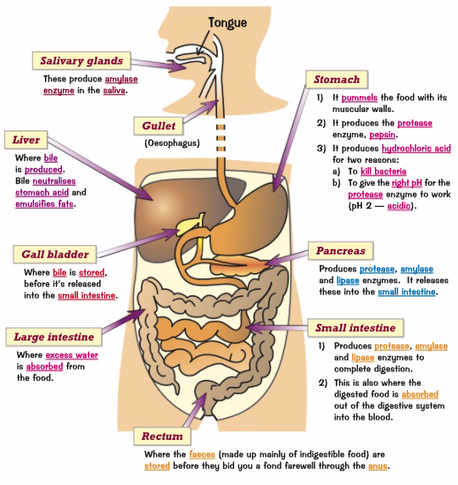

**Food Tests – Practical**

* You can identify what food molecule a sample contains, to do this, you need to create a food sample and the specific test
  + To do the food sample, you have to:
    - Get a piece of food and break it up using a pestle and mortar
    - Transfer the ground up food to a beaker and add some distilled water
    - Stir well to dissolve the food
    - Filter the solution using a funnel lined with filter paper to get rid of any solid bits of food
* TESTING FOR SUGARS:
  + Benedict’s test
    - There are two types of sugars, reducing and non-reducing, this checks for non-reducing
      * Put 5cm3 of food sample into a test tube
      * Prepare a water bath so that it’s set to 75°C
      * Add some benedict’s solution to the test tube (about 10 drops) using a pipette
      * Place a test tube in the water bath using a test tube holder and leave it in there for 5 minutes
        + make sure the tube is facing away from you
      * If the sample contains a reducing sugar, the solution in the test tube will change from the normal blue colour to
        + Green, yellow or brick-red - depending on how much sugar is in it
* TESTING FOR STARCH
  + Iodine solution
    - Put 5cm3 of food sample into a test tube
    - Add a few drops of iodine solution and gently shake the tube to mix
    - If it contains starch, the colour will change from browny-orange
      * To a black or a blue-black
* TESTING FOR PROTEINS
  + Biuret test
    - Put 2cm2 of food sample into a test tube
    - Add 2cm2 of biuret solution to the sample and mix the contents by gently shaking it
    - If the food sample contains protein it will change from blue
      * To a pink or purple colour
* TESTING FOR LIPIDS
  + Sudan III test
    - Put 5cm3 of food sample(unfiltered) into a test tube
    - Use a pipette to add 3 drops of Sudan III stain solution to the test tube and gently shake
    - Sudan III stains lipids and if it contains lipids, the mixture will separate into two layers
      * The top layer will be bright red.
      * If no lipids are present, no separate red layer will form on top of the liquid

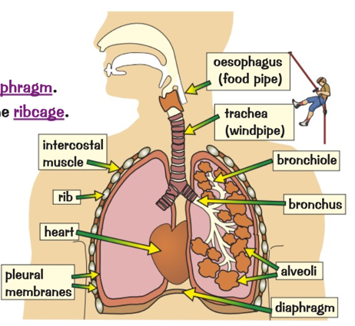**The lungs**

* Location of lungs
  + The lungs are in your thorax which is the top part of your body
  + It is separated from the lower part of the body by the diaphragm
  + The lungs are protected by the ribcage
  + They’re surrounded by the pleural membranes
* What they do
  + The air that you breathe in goes through the trachea (windpipe)
    - This then splits into two tubes called bronchi (each one is called bronchus)
    - Each bronchus takes the air to a lung
  + The bronchi split into progressively smaller tubes called bronchioles
  + The bronchioles end up at small bags called alveoli where the gas exchange takes place
* Gas exchange
  + The lungs contain millions of little air sacs called alveoli which are surrounded by a network of blood capillaries
    - This is where gas exchange occurs
  + The blood passing next to the alveoli is returning to the lungs from the rest of the body, therefore it has a lot of carbon dioxide and not much oxygen
    - The oxygen diffuses out of the alveolus, (high concentration) into the blood (low concentration)
    - The carbon dioxide diffuses out of the blood (high concentration) into the alveolus (low concentration) to be breathed out
  + When the blood reaches the body cells,
    - Oxygen is released from the red blood cells (high concentration) and diffuses into the body cells (low concentration)
    - At the same time:
      * Carbon dioxide diffuses out if the body cells (high concentration) into the blood (low concentration)
      * Where the blood is then carried back to the lungs
* Breathing rate:
  + Number of breaths / number of minutes

**Circulatory system – The Heart**

* The circulatory system is made up of the heart, blood vessels and blood
* Humans have a double circulatory system – two circuits joined together
* In the first circulatory system
  + The right ventricle pumps deoxygenated blood to the lungs
    - This is to take in oxygen
    - The blood then returns to the heart
* In the second circulatory system
  + The left ventricle pumps oxygenated blood all around the other organs of the body
    - The blood gives up its oxygen at the body cells
    - Deoxygenated blood then returns to the heart to be pumped out to the lungs again
* What does the heart do?
  + 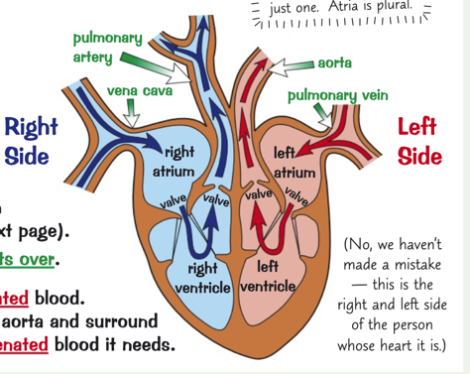The heart is a pumping organ
    - It keeps the blood flowing around the muscle
    - The walls of the heart are mostly made of muscle tissue
  + The heart has valves to make sure the blood flows in the right direction
    - Valves make sure the blood doesn’t flow backwards
  + The heart has 4 chambers
    - Right atrium
    - Right ventricle
    - Left atrium
    - Left ventricle
* How does it work?
  + Blood flows into the two atria (plural for atrium)
    - The blood in the left atrium comes from the pulmonary vein
    - The blood in the right atrium comes from the vena cave
  + The atria contract
    - This pushes the blood into the ventricles (left and right)
  + The ventricles contract
    - This forces the blood into the pulmonary artery and the aorta
    - Which then take it out of the heart
  + The blood then flows to the organs through the arteries and returns through the veins
* The heart also needs its own supply of oxygenated blood
  + Arteries called coronary arteries branch off the aorta and surround the heart, making sure that it gets all the oxygenated blood it needs
* Pacemaker – **how often your heart contracts to pump blood around the body**
  + Your resting heart rate is controlled by a group of cells in the right atrium wall which act as a pacemaker
  + These cells produce a small electric impulse which spreads to the surrounding muscle cells causing them to contract
  + An artificial pacemaker is often used to control heartbeat if the natural one doesn’t work.
    - It is a device implanted under the skin and has a wire going to the heart
    - It produces an electrical current to keep the heart beating regularly

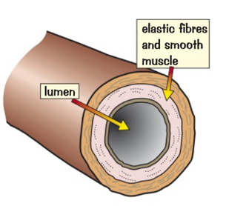**Circulatory Systems – Blood Vessels**

* Arteries
  + **These carry blood away from the heart**
    - The heart pumps the blood out at high pressure
      * Therefore, the artery walls are strong and elastic
    - The walls are thick compared to the size of the lumen
    - They contain thick layers of muscle to make them strong
    - They have elastic fibres to allow them to stretch and spring back
* Capillaries
  + 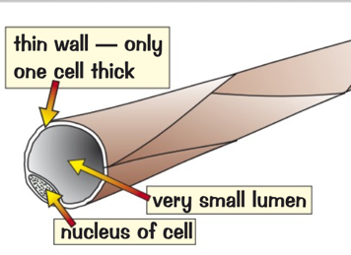**These are involved in the exchange of materials at the tissues**
    - Arteries branch into capillaries
    - They are really tiny, too small to see
    - They carry blood really close to every cell in the body
      * This is to exchange substances with them
    - They have permeable and thin walls
      * Being permeable makes it easier for substances to diffuse in and out
      * The thin walls increase the rate of diffusion
    - They supply food and oxygen and take away waste like CO2
* 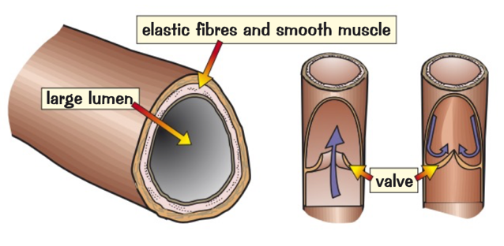Veins
  + **These carry blood back to the heart**
    - Capillaries join up to make veins
    - The blood is at lower pressure
      * This means that walls don’t need to be as thick as artery walls
    - They have a bigger lumen than arteries
      * Despite the lower pressure, this helps the blood flow
    - They have valves to keep blood flowing the right direction
* Rate of blood flow
  + Volume of blood / number of minutes

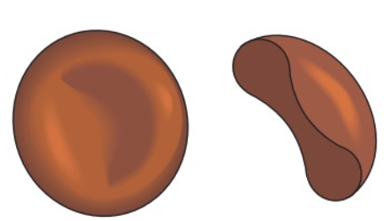**Circulatory Systems – Blood Vessels**

* Red blood cells
  + Their job is to carry oxygen from the lungs to all the cells in the body
    - Their shape is a biconcave disc
      * This gives a large surface area for absorbing oxygen
    - They don’t have a nucleus; this allows more room to carry oxygen
    - They contain a red pigment to haemoglobin
      * In the lungs, haemoglobin binds to oxygen to become oxyhaemoglobin
      * In body tissues the reverse happens
        + The oxyhaemoglobin splits and makes oxygen and haemoglobin
        + This releases oxygen to the cells
* White blood cells
  + Their job is to defend against infection
    - Some can change shape to engulf unwelcome microorganisms
      * This process is called phagocytosis
    - Others produce antibodies to fight microorganisms
      * They also produce antitoxins to neutralise any toxins produced by the microorganism
    - They have a nucleus
* Platelets
  + Their job is to help blood clot
    - They are small fragments of cells
    - They have no nucleus
    - They help the blood to clot at a round
      * This stops all your blood pouring out
      * It also stops microorganisms getting in
    - Lack of platelets can cause excessive bleeding and bruising
* Plasma
  + This is the liquid that carries everything in blood
    - They carry:
      * Red blood cells
      * White blood cells
      * Platelets
      * Nutrients
        + Glucose
        + Amino acid

These are the soluble products of digestion

* + - * Carbon dioxide
        + From organs to lungs
      * Urea
        + From liver to kidneys
      * Hormones
      * Proteins
      * Antibodies
      * Antitoxins

**Cardiovascular disease**

Cardiovascular disease - **A disease of the heart or blood vessels**

* Coronary heart disease
  + When the coronary arteries that supply the blood to the muscle of the heart get blocked by layers of fatty material building up
  + This causes the arteries to become narrow
    - This means blood flow is restricted and there’s a lack of oxygen to the heart muscle
      * This can lead to heart attack
* Stents
  + Stents are tubes that can be inserted into arteries
    - This keeps them open making sure the blood can pass through to the heart muscles
      * This keeps the person alive
    - Stents are a way of lowering the risk of a heart attack in people with coronary heart disease
      * They are effective for a long time and the recovery time is relatively quick
    - On the downside, there can be complications during the operation, for example:
      * Heart attacks
      * Risk of infection
      * A blood clot near the stent
        + This is called thrombosis

|  |  |
| --- | --- |
| ***ADVANTAGES*** | ***DISADVANTAGES*** |
| You don’t need major surgery | Risk of there being complications during the operation |
| Lower the risk of heart attacks for people with CHD | Risk of damage to the artery |
| Effective for a long time | Risk of infection |

* Statins
  + Statins reduce cholesterol in the blood
    - Cholesterol is an essential lipid that your body produces and needs to function properly
      * However too much of a certain type of cholesterol (LDL) can cause health problem
    - Having too much bad cholesterol in the bloodstream can cause fatty deposits to form in the arteries
      * This can lead to coronary heart disease
  + Statins are drugs that can reduce the amount of bad cholesterol present in the blood stream
    - This slows down the rate of fatty deposits forming

|  |  |
| --- | --- |
| ***ADVANTAGES*** | ***DISADVANTAGES*** |
| Reduce the risk of stroke, heart attacks and coronary heart disease | Long term drug which need to be taken regularly |
| Increase the amount of beneficial cholesterol | Can have serious negative side effects |
| May also help prevent other diseases | Effect isn’t instant, it can take a while for the effects to kick in |
| They’re easy to take as they are oral consumption | Easy to forget to take them |

* Artificial heart
  + If a patient has heart failure, doctors may perform a heart or heart and lung transplant using donor organs from people who have recently died
  + However, if there aren’t any donor organs available, they may fit an artificial heart
    - Artificial hearts are mechanical devices that pump blood for a person whose own heart has failed.
      * They are usually only a temporary fix
        + This is to keep the person alive until a donor heart can be found
        + Or to allow their heart to rest and heal
      * They can be used as a permanent fix to reduce the need of a donor heart

|  |  |
| --- | --- |
| ***ADVANTAGES*** | ***DISADVANTAGES*** |
| They’re less likely to be rejected | Can lead to bleeding and infection |
| The body doesn’t recognise them as foreign objects | They don’t work as well as healthy hearts |
| It allows the patient to be alive | Parts of the heart could wear out or the electrical motor could fail |
| It can relieve stress on the heart | Blood doesn’t flow through artificial hearts as smoothly which can cause blood clots |

* Artificial heart valves
  + In some people heart valves may become faulty
    - The damage to the valve can:
      * Prevent the valve from opening fully
        + This means not enough blood will go through
      * Cause the heart valve to develop a leak
        + This means that the blood doesn’t circulate as effectively
  + Severe valve damage can be treated by replacing the valve
    - Replacement valves can be:
      * Taken from humans or other mammals
        + These are biological valves
      * Man-made
        + These are mechanical valves
    - Replacing a valve is less drastic than a whole heart transplant however it is still a major surgery

|  |  |
| --- | --- |
| ***ADVANTAGES*** | ***DISADVANTAGES*** |
| Reduces the risk of blood not circulating properly | Can cause blood clots |
| Reduce the risk of not having enough blood circulating | You have to have surgery |

* + - * It can cause blood clots
  + Mechanical VS BIOLOGICAL
    - Mechanical last a lifetime
      * Biological need to be replaced
    - Mechanical increase the risk of blood clots, therefore drugs need to be taken to stop this
      * Biological are less likely to clot
* Artificial Blood
  + When someone loses a lot of blood, their heart can still pump the remaining red blood cells around to get oxygen to their organs
    - This is as long as the volume of their blood can be topped up
  + Artificial blood is a blood substitute used to replace the lost volume of blood
    - It is safe to use as long as no air bubbles get into the blood
      * They can be used to keep people alive even if they’ve lost 2/3 of their red blood cells
        + This is used to give the body enough time to make new blood cells

If it doesn’t happen then they need a blood transfusion

* + Scientists are working on a way for artificial blood to replace the function of red blood cells

**Health and Disease:**

Health is the state of physical and mental wellbeing. Diseases are often responsible for causing ill health

* Communicable diseases
  + These are diseases that can spread from people to people or between animals and people.
  + They can be caused by thing like:
    - Bacteria, viruses, parasites and fungi
  + They’re sometimes described as contagious or infectious diseases.
  + Examples include:
    - Measles and malaria
* Non-communicable diseases
  + These are diseases that cannot spread between people or between animals and people
  + They generally last for a long time and get worse slowly
  + Examples include:
    - Asthma, cancer and coronary heart disease